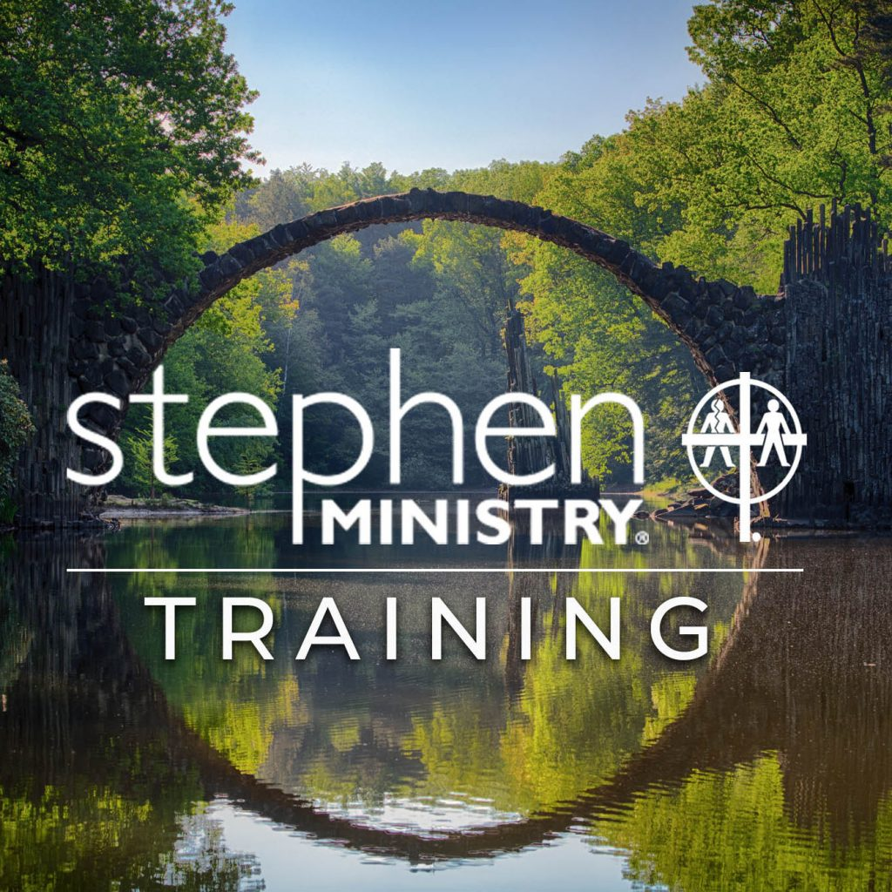
Are you called to more?

Want to join Our Lady of Grace’s Stephen Ministry team?

Stephen Minister Training starts soon.
Training every other Monday from 6-9pm at Mary Mother of the Church in Burnsville
Monday November 27th through Monday April 8th
Applications for Stephen Ministers due by November 15th
Call Beryl Schewe for more information or to set up an interview
952-999-9035
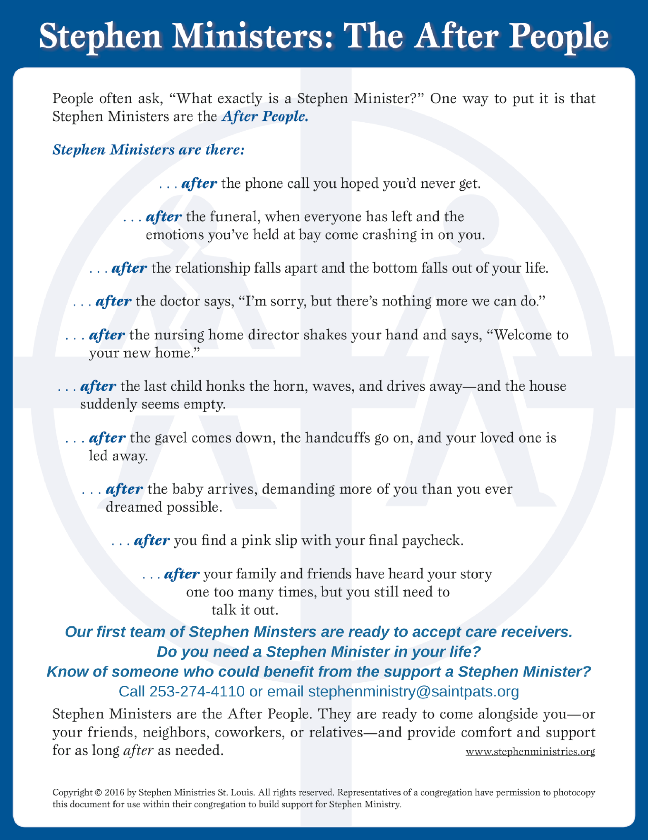
Call Beryl Schewe at 952-999-9035 or BerylSchewe@olgparish.org

